INDICES
Pearson Edexcel - Tuesday 6 November 2018 - Paper 1 (Non-Calculator) Foundation Tier

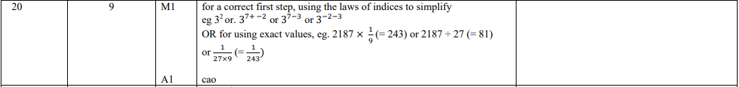

Pearson Edexcel - Thursday 7 June 2018 - Paper 2 (Calculator) Foundation Tier

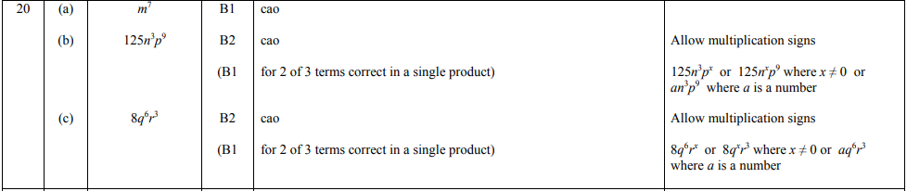

Pearson Edexcel - Monday 6 November 2017 - Paper 2 (Calculator) Foundation Tier

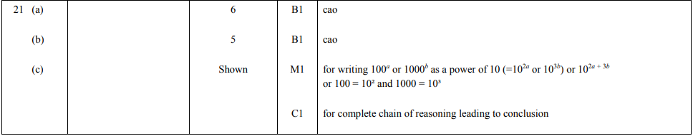
OCR Wednesday 8 November 2017– Morning (Calculator) Foundation Tier

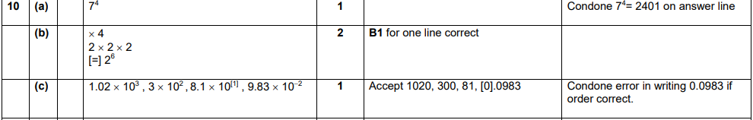
OCR Tuesday 13 June 2017 – Morning (Calculator) Foundation Tier

AQA Tuesday 21 May 2019 – Morning (Non-Calculator) Foundation Tier

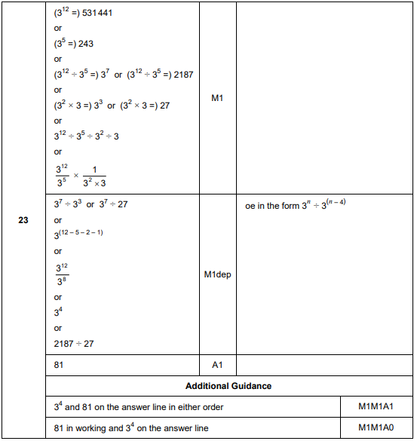
AQA Thursday 24 May 2018 – Morning (Non-Calculator) Foundation Tier

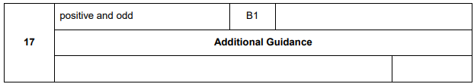

AQA Tuesday 13 June 2017 Morning– Morning (Calculator) Foundation Tier

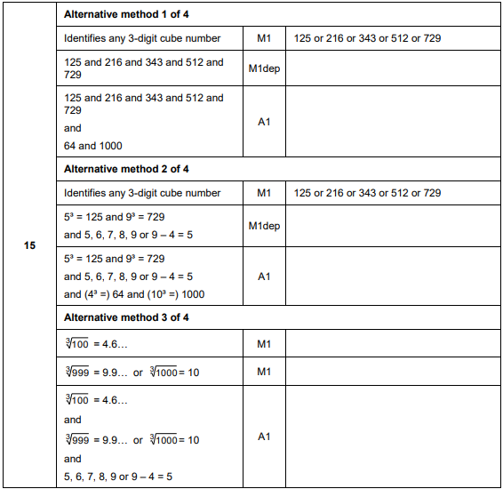
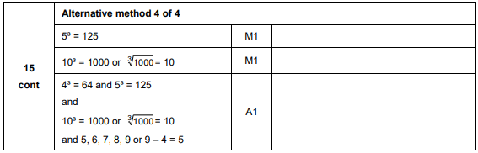

AQA Sample Paper 3– Morning (Calculator) Foundation Tier

